**Roll No.- 61653**

**PROJECT REPORT**

**On**

# “*To study the consumer satisfaction towards Bajaj bikes*”

**For**

**“ *R & R MOTORS* ”**

SUBMITTED BY: -

**DEV BAYLA**

IN

PARTIAL FULFILMENT OF THE REQUIREMENT OF THE

DEGREE OF MASTER OF SCIENCE IN OPERATIONAL RESEARCH

TO

THE DEPARTMENT OF OPERATIONAL RESEARCH

FACULTY OF MATHEMATICAL SCIENCES

NEW ACADEMIC BLOCK

UNIVERSITY OF DELHI

Delhi-110007

2020

|  |  |
| --- | --- |
| **Name of the Student** | **DEV BAYLA** |
| **Date of Commencement of Project** | **3rd FEB ,2020** |
| **Date of Submission of Project** | **31th MAY, 2020** |
| **Title of the Project** | “*To study the consumer satisfaction towards Bajaj bikes*“ |
| **Project Mentor** | **Anil Garg** |
| **Name and address of the :**  **Organization** | **R & R MOTORS,Narnaul(Hr.)** |
| **Supervisors from the teaching faculty** | **Professors**  **Prof.(Dr.) Anu Gupta Aggarwal**  **Prof.(Dr.) KK Aggarwal**  **Prof.(Dr.) Pankaj Gupta**  **Prof.(Dr.) Chandra K. Jaggi**  **Prof.(Dr.) Prakash C. Jha**  **Prof.(Dr.) Preeti Wanti Srivastava**  **Associate Professors**  **Dr. Ompal Singh**  **Assistant Professors**  **Dr. Adarsh Anand**  **Dr. Vandana Khaitan**  **Dr. Aditi Khanna**  **Mr. Kaushal Kumar**  **Dr. Mukesh Kumar Mehlawat** |

**CERTIFICATE**

This is to certify that the Project Report titled “*To study the consumer satisfaction towards Bajaj bikes*” is my original work carried out at “Bajaj Auto Private Limited” in the year 2020 and has been submitted for partial fulfillment of the course M.Sc. Applied Operational Research. This project report has not been submitted earlier in full or in part for any other University or Institution to the best of my knowledge.

DEV BAYLA

M.Sc (Final) Applied Operational Research

Department Of Operational Research

Faculty of Mathematical Sciences

University of Delhi

Delhi-110007

Professor(Dr). Pankaj Gupta

Head,

Department Of Operational Research

Faculty of Mathematical Sciences

University of Delhi

Delhi-110007

**ACKNOWLEDGEMENT**

I express my sincere gratitude to the Operational Research Faculty for the timely needful guidance, help, managerial support and co-operation

at various levels during the project study.

I wish to express my heartfelt gratitude to Dr. Anu Gupta Aggarwal for their inevitable guidance, co-operation and suggestions in planning and execution of the project.

I am highly indebted to Mr. Anil Garg(Manager), R & R MOTORS ,Narnaul for giving me an opportunity to undertake this project.

Last but not the least, I would like to thanks all the respondents for giving me their precious time and relevant information and experiences I required, without which this project would have been a different story.

Pappu

M. Sc. (Final) Applied Operational Research

Department of Operational Research

University of Delhi

Delhi – 110007

**CONTENTS**

|  |  |
| --- | --- |
| S.No. | Topic |
| 1. | **Introduction to Operational Research** |
| 2. | **Company Profile** |
| 3. | **Marketing Research** |
| 4. | **Customer Satisfaction** |
| 5. | **Questionnaire Design** |
| 6. | **Factor Analysis** |
| 7. | **Research Objective and Methodology** |
| 8. | **Data Analysis** |
| 9. | **Swot Analysis** |
| 10. | **Questionnaire used for this survey** |
| 11. | **Bibliography** |

1. ***INTRODUCTION TO OPERATIONAL RESEARCH***

|  |
| --- |
| THE OPERATIONAL RESEARCH TOOLBOX  OR is primarily a problem-solving process. However, over the years OR has accumulated a wide set of tools, models, and methods widely applicable to operations problems. They include:  Business models Decision analysis Optimization  Probabilistic system Statistics Process Maps  Decision Trees Linear Programming Stochastic  Processes Data Analysis Supply Chain  Analysis Multi Criteria Methods Integer  Programming Queueing Theory Regression &  Forecasting Transportation Networks Risk  Analysis Network Optimization Simulation  Analysis Survey Methods |

###### **DIFFERENT DEFINITIONS OF OPERATIONAL RESEARCH**

“The high tech field of OR offers numerous excellent opportunities to boost performance immediately. Yet OR Practitioner time remains to skim the cream before everyone wakes up to the projects. When most do wake up,

USA companies that are not taking full advantage of OR will leave serious money on the table and be outflanked competitors.”

--**RandRobinson**

“Operations Research is the systematic application of quantitative methods, techniques and tools to the analysis of problems involving the operations of systems.”

**--Daellanbach and George 1978**

“OR is a scientific knowledge through interdisciplinary team effort for the purpose of determining the best utilizations of limited resources.”

**--H A Taha**

““OR is the application of scientific methods, techniques and tools to problems involving the operations of a system so as to provide those in control of the system with *optimum* *solutions* to the problem.”

**--C W Churchman, R L Ackoff & E L Arnoff**

Operations Research may be described as a scientific approach to decision-making that involves the operations of organizational system.”

**--F S Hiller and G J Lieberman, 1980**

“OR is the art of giving bad answers to the problems which otherwise have worse answers.”

**--T L Satty**

“OR is the scientific approach to problem solving for executive management.”

**- -H M Wagner**

**OPERATIONAL RESEARCH – *AN OVERVIEW***

Operational Research (OR) is an interdisciplinary branch of applied [mathematics](http://en.wikipedia.org/wiki/Mathematics) and [formal science](http://en.wikipedia.org/wiki/Formal_science) that uses methods like [mathematical modeling](http://en.wikipedia.org/wiki/Mathematical_model), [statistics](http://en.wikipedia.org/wiki/Statistics), queuing theory, game theory, decision analysis, and simulation to arrive at optimal or near optimal solutions to complex problems. Because of the computational nature of these fields, OR also has ties to computer science, and operations researchers regularly use custom-written or off-the-shelf software.

Operational research is distinguished by its frequent use to examine an entire [system](http://en.wikipedia.org/wiki/System), rather than concentrating only on specific elements (though this is often done as well). An operational researcher faced with a new problem is expected to determine which techniques are most appropriate given the nature of the system, the goals for improvement, and constraints on time and computing power.

The use of OR is hidden from our daily lives to such an extent that most people would be surprised at how much OR impacts them. This includes the schedule for the bus they ride, the crews on the airplane they fly, the route their garbage truck takes, the prices of their car rentals and air tickets, the inventory in their favorite store, whether they can get an answer from a call centre, how trees are sawn into products, and where and how many spares are provisioned.

**Professor P.M.S. Blackett** was one of the first scientists to define the essential elements of Operational Research, also known as the **FATHER OF OPERATIONAL RESEARCH**. In October 1941 he wrote a Report on Operational Research which is considered by many to be the original 'definition of Operational Research'. Of the use of scientists at the operational level he said;

*'The object of having scientists in close touch with operations is to enable operational staffs to obtain scientific advice on those matters which are not handled by the service technical establishments... Operational staff provides the scientists with the operational outlook and data. The scientists apply scientific methods of analysis to this data, and are thus able to give useful advice. The main field of their activity is clearly the analysis of actual operations, using as data the material to be found in an operations room, e.g. all signals, track charts, combat reports, meteorological information, etc. . . .'*

In 1947 **Dr. Kittel** described OR thus: ***'****Operations Research is a scientific method for providing executive departments with a quantitative basis for decisions.'* A year later **Sir Charles Good eve** summed it up as '*quantitative common-sense’.*

The first definitions of OR date from the 1950's. The father of OR, **Professor P.M.S. Blackett** gave the first definition

'OR is a scientific activity conducted for executives'.

In 1947, Dr. Kittel’s expands a little bit into his well-known definition of operational research as “A scientific method for providing executives with a quantitative basis for decisions.”

In 1976 the UK Operational Research Society defined Operational Research as:

“...Is the application of the methods of science to complex problems arising in the direction and management of large systems of men, machines, materials and money in industry, business, government and defence. The distinctive approach is to develop a scientific model of the system, incorporating measurements of factors, such as chance and risk, with which to compare the outcome of alternative decisions, strategies or controls. The purpose is to help management determine its policies and actions scientifically....”

Operations Research (OR) and the Management Sciences (MS) are the professional disciplines that deal with the application of information technology for informed decision-making.

Operations research is the science of decision making. OR methods involve identifying business problems and possible scenarios for solving them. These variables are modeled using various forms of applied mathematics implemented as software algorithms. On a more granular level, the OR professional collects the relevant data to instantiate the model, optimizes it, and then evaluates the results, which provide business professionals with a suggested course of action.

OR can help the following kinds of business questions:

* How should the fleet of delivery trucks be allocated to meet customer needs while making the best use of drivers?
* What's the best breakdown of the marketing budget to maximize customer-response rates?
* Where warehouses should be located to minimize transportation costs?
* What's the impact of faster machinery on the factory-production process?

**HISTORY OF OPERATIONAL RESEARCH**

The term, Operations research, was first coined in 1940 by McClosky and Trefthen in a small town Bowdsey, of the United Kingdom. This new science came to existence in military context. During World War II, military management called on scientists from various disciplines and organized them into teams to assist in solving strategic and tactical problems associated with allied military effort, because they were simply too complicated to expect adequate solutions from any one individual, or even a single discipline and to discuss, evolve and suggest ways and means to improve the execution of various military projects .By their joint efforts, experience and deliberations, they suggested certain approaches that showed remarkable progress. This new approach to systematic and scientific study of the operations of the system was called the Operations Research or Operational Research. (Abbreviated as O.R.).

After the war, many of the scientists who had been active in the military O.R. groups turned their attention to the possibilities of applying a similar approach to civilian problems. Some returned to universities and provide a sound foundation for many of the techniques that had been developed earlier and also develop new techniques. And in 1950, Operational Research achieved recognition as subject worthy of academic study**.**

In **India**, operations research came into existence in 1949 with the opening of an O.R. unit at the regional research laboratory at Hyderabad. At the same time another group was set up in defense science laboratory which devoted itself to the problems of store, purchase and planning in 1953, an O.R. unit was established in the Indian statistical institute, Calcutta, for the application of O.R. methods in national planning and survey .O.R. society of India was formed in 1957. It became a member of international federation of O.R. societies in 1959. The first conference of O.R. society of India was held in Delhi in 1959.it was also decided to start journals of operations research, which took a practical shape in 1963 in form of ‘OPSEARCH’. In the same year, India along with Japan became a member of International Federation of Operational Research societies (IFORS) with headquarters in London.

In India Planning Commission made the use of O.R. techniques for planning the optimum size of the carevelle fleet of Indian Airlines. In the industrial sector, in spite of the fact that opportunities of O.R. work at present are very much limited, organized industries in India are gradually becoming conscious about the role of Operational research.

###### **SIGNIFICANT FEATURES OF OPERATIONAL RESEARCH APPROACH**

1. **INTER DISCIPLINARY APPROACH**: O.R. is interdisciplinary in nature and requires a team approach to a solution of the problem, because managerial problems have economic, psychological, biological, sociological and engineering aspects. Hence it requires a blend of people with expertise in the area of mathematics, statistics, engineering, economics, management, computer science and so on.
2. **Methodological (Scientific) Approach**: OR employs scientific methods consists of observing & defining the problem formulation and testing the hypothesis; and analyzing the results of the test the data so obtained are then used to decide whether the hypothesis should be accepted or not.
3. **Wholistic Approach** : While arriving at a decision, an O.R. team examines the relative importance of all conflicting and multiple objectives and the validity of claims of various departments of the organization from the perspective of whole organization
4. **Objective Approach**: An O.R. approach seeks to obtain an optimal solution to the problem under analysis. For this, a measure of desirability is defined, based on the objectives of the organization.

**MODELS IN OPERATIONAL RESEARCH**

A model in O.R. is a simplified representation of an operation or a process in which only the basic aspects or the most important features of a typical problem under investigation are considered. Constructing a model aids inserting the complexities and possible uncertainties attending a decision making problem into a logical framework amenable to comprehensive analysis. Such a model clarifies the decision alternatives their anticipated effects, indicate the relevant data for analysis the alternatives, and leads to informative conclusions.

**CLASSIFICATION OF MODEL**

Although the classification of models is a subjective problem, they may be distinguished as follows:

**MODELS BY DEGREE OF ABSTRACTION**

These models are based on the past data/information of the problems under consideration and can be categorized into

(a) language models

(b) case studies.

**MODELS BY FUNCTION**

These models consist of

(a) Descriptive Models

(b) Predictive Models

(c) Normative Models.

1. **DESCRIPTIVE MODELS**

These models describe, explain, and predict facts and relationships among the various activities of the problem. These are used to describe mathematically some particular aspects of the system being modeled. These models do not have an objective the system being modeled. These models do not have an objective function as apart of the model to evaluate decision alternatives. Thus, in a descriptive model it is possible to get information as to how one or more factors charge as a result of changes in other factors.

1. **PREDICTIVE MODELS**

These model indicates that “if this occurs then that will follow” .they relate independent and dependent variables and permit trying out, ’what if’ questions. In other words, these models are used to predict the outcomes due to a given set of the alternatives for the problem. These models do not have an objective function as a part of the model to evaluate decision alternatives.

1. **NORMATIVE (OR OPTIMIZATION) MODELS**

These models provide the “best” or “optimal” solution to the problems subject to limitation on the use of resources. These models provide recommended courses of action. For example, in mathematical programming, models are formulated for optimizing the given objective function, subject to certain restrictions and non negativity of the decision variables.

**MODELS BY STRUCTURE**

These models are represented as:

(a) Iconic Models

(b) Analogue Models

(c) Symbolic Models.

1. **ICONIC MODELS**

Iconic model retains some of the physical properties and characteristics of the system they represent. An iconic model is either in an idealized form of or a scaled scale version of the system. In the other words, such models represent the system as it is by scaling it up or down.

Examples of iconic models are blue prints of a home, globes, photographs, drawing, atom etc.

Iconic models are easy to observe, build and describe but difficult to manipulate and not very useful for the predictions. Commonly these models represent a static event.

1. **ANALOGUE MODELS**

Analogue models are more abstract then iconic ones for there is no ‘look- alike’ correspondence between these models and real life items. They are built by utilizing one set of properties to represent another set of properties. For instance a network of pipes through which water is running could be used as a parallel for understanding a distribution of electric current. Graphs and maps parallel in various colors are analogue models, in which different color correspond to different characteristics. A floe process chart is analogue model which represents the order of occurrence of various events to make a product.

1. **MATHEMATICAL OR SYMBOLIC MODELS**

These models are more abstract in nature. They employ asset of mathematical symbols to represent the components of the real system. These models are more general and precise.

**MODELS BASED ON DEGREE OF CERTAINITY**

1. **DETERMINISTIC MODELS**

If all the parameters, constants and functional relationships are assumed to be known with certainty when decision is made, then the model is said to be deterministic. Thus in such a case, the outcome associated with particular course of action is known. That is for a specific set of input values there is uniquely determined output which represents the solution of the model under conditions of certainty. Linear programming models are example of deterministic models.

1. **PROBABILISTIC (STOCHASTIC) MODELS**

Models in which at least one parameters or decision variables is a random variable are called probabilistic models. These models reflect to some extent the complexity of the real world and the uncertainty surrounding it.

**MODELS BY EXTENT OF GENERALITY**

These models can be categorized into

(a) Specific models

(b) General models

1. **SPECIFIC MODELS**

When a model presents a system at some specific time, it is known as a specific model. In these models if time factor is not considered, then they are termed as static model and dynamic model otherwise.

1. **GENERAL MODELS**

Simulation and heuristic models fall under general models. These models are mainly used to explore alternative strategies which have been overlooked previously. These models do not yield any optimum solution to the problem, but give a solution to the problem depending on the assumptions based on the past experience.

**METHODOLOGY OF OPERATIONAL RESEARCH**

The systematic methodology developed for operations research study deals with problems involving conflicting multiple objectives, policies and alternatives. O.R. in the final analysis is a scientific methodology which is applied to the study of operations of large complex organization and activities with a view to assessing the overall implications of various alternative courses of action, thus providing an improved basis for managerial decision.

Then O.R. approach to problem solving consists of the following six steps:

1. **Formulation of the problem:** It involves analysis of the physical system, setting up of objectives, determination of restriction constraints against which decision should be adopted, alternative courses of action and measurement of effectiveness.
2. **Construction of a mathematical model:** after formulation of the problem, the next step is to express all the relevant variables of the problem into a mathematical model. A generalized mathematical model might take the form:

**E = f (xi, yj)**

1. **Deriving the solution from the model:** once the mathematical model is formulated, the next step is to determine the values of the decision variables that optimize the given objective function. This deals with the mathematical calculations for obtaining the solution to the model.
2. **Validity of the model:** the model should be validated to measure its accuracy. That is in the order for a model to be useful, the degree to which it actually represents the system or problem being modeled must be established. A model is valid or accurate if (a) it contains all the objectives, constraints, and the decision variables relevant to the problem, (b) the objectives, constraints, and the decision variables are all relevant to, or the actually part of the problem, and (c) the functional relationships are valid.
3. **Establishing control over the solution:** After testing the model and its solution, the next step of the study is to establish control over the solution. By proper feedback of the information on the variables which deviated significantly. As soon as one or more of the control variables change significantly, the solution goes out of the control in such as situation the model may accordingly be modified.

6. **Implementation of the final results:** Finally, the tested result of the model is implemented to work. This would basically involve a careful explanation of the solution to be adopted and its relationship with the operating realities. This stage of O.R. investigation is executed primarily through the cooperation of both the O.R. experts and those who are responsible for managing and operating the system.

**SCIENTIFIC METHOD IN O.R.**

The scientific method in operations research consists of the following three phases:

**Judgment phase:** This phase includes:

1. Identification of the real life problem.
2. Selection of an appropriate goal and the values of the various variables related to the goals.
3. Appropriate scale of measurement
4. Formulation of an appropriate model of the problem, abstracting the essential formulation so that the solution at the decision maker’s can be sought.

**Research phase:** This phase is the largest and longest among the other two. However other two also equally important as they provide basis for a scientific method. This phase utilizes:

(i) Observations and data collection for better understanding of what the problem is.

(ii) Formulation of hypothesis and models

(iii) Observation and experiment to test the hypothesis on the basis of

additional data

(iv) Analysis of the available information and verification of the hypothesis using

pre established measures of effectiveness

(v) Predictions of the various results from the hypothesis

(vi) Generalization of the results and consideration of alternative methods.

**Action Phase:** This phase consist of making recommendations for decision process by those who first posed the problem for consideration, or by anyone in a position to make a decision influencing the operation in which the problem occurred.

APPLICATIONS OF OPERATIONAL RESEARCH

Some of the industrial /government / business problems which can be analyzed by O.R. approach have been functional area wise as follows:

**Finance, budgeting and investment**

1. Cash flow analysis, long range capital requirement, dividend policies, investment portfolios.
2. Credit policies, credit risks and delinquent account procedures .
3. Claim and complaint procedures.

### Marketing

1. Product selection, timing, competitive actions.
2. Advertising media with respect to time and cost.
3. Number of salesman, frequency of calling of accounts etc.
4. Effectiveness of marketing research.

**Physical distribution**

1. Location and size of warehouses, distribution centers, retail outlets etc.
2. Distribution policy.

**Purchasing procurement and exploration**

1. Rules for buying.
2. Determining the quantity and time to purchase.
3. Bidding policies and vendor analysis.
4. Equipment replacement policies.

#### Personnel

1. Forecasting the manpower requirement, recruitment policies and assignment jobs.
2. Selection of suitable personnel with due consideration of age and skills, etc.
3. Determination of optimum number of persons for each centre.

#### Production

1. Scheduling and sequencing the production run by proper allocation of machines.
2. Calculating the optimum product mix.
3. Selection location and design of the sites for the production plant.

**Research and development**

1. Reliability and evaluation of alternative designs.
2. Control and developed projects.
3. Co-ordination of multiple research projects.
4. Determination of time and cost requirements.

USES OF OPERATIONAL REASEARCH

Formulation of industrial problems may be generalized into different groups of classical problems, the package programme for which is available for mechanization and manual solutions.

Various problem of optimization can be brought to the model of linear programme for which solution is available. While formulating the problem, the class of the problem is to be decided and the parameters are to be defined accordingly.

Inventory control, production planning, product mix, transportation problem, etc. are very common to the industries. The cost reduction with the help of these tools is very much powerful in comparison to any other conventional method. We can enumerate the advantages of these techniques as :

1. Optimum use of production factors: linear programming techniques indicate how a manager can most effectively employ his production factors by more efficiently selecting and distributing these elements.
2. Improved quality of decision: the computation table gives a clear picture of happenings within the basic restriction and the possibilities of compound behavior of the elements involved in the problems. The effect on the profitability due to changes in the production pattern will be clearly indicated in the table .e.g. simplex table.
3. Preparations of future managers: these methods substitute a means for improving knowledge and skills of your manager.
4. Modification of mathematical solution: O.R. presents a possible practical solution when one exists, but it is always a responsibility of the manager to accept or modify the solution before its use. The effects of these modifications may be evaluated from the computational steps and tables.
5. Alternative solution: O.R. techniques will suggest all the alternative solution available for the same profit so that the management may decide on the basis of its strategies.

LIMITATIONS OF OPERATIONAL RESEARCH

O.R. has certain limitations. These limitations are as follows:

1. **Magnitude of computation:** O.R. tries to find out the optimal solution taking all the factors into account. In the modern society , these factors are numerous and expressing them in quantity and establishing relationship among these , requires huge calculations. All these calculations cannot be handled manually and require electronic computers which bear a very heavy cost. Thus the use of O.R. is limited to only very large organizations.
2. **Absence of qualification:** O.R. provides solution only when all the elements related to a problem can be quantified. The tangible factors such as product, price, etc., can be expressed in terms of quantity , but intangible factors such as human relations etc. cannot be quantified. Thus these intangible elements of the problem are excluded from the study, though these might be equal or more important than quantifiable intangible factors as far as possible.
3. **Distance between managers and operations research:** O.R. being specialist job requires a mathematician or a statistician, who might not be aware of business problems. Similarly a manager may fail to understand the complex working of O.R. Thus, there is a gap between one who provides the solution and one who uses a solution. Thus, the manager who becomes suspicious about the optimal solution. This problem is mainly of training. Both the persons should have a working knowledge of each others job to have better understanding of insights of the problem and its optimal solution.

CHARACTERISTICS OF OPERATIONAL RESEARCH

1. Such a team, when confronted with a problem, determines the solution of the problem by following inter-disciplinary approach. Every expert of the team tries to abstract the essence of the problem and determines if the same type of problem has been previously undertaken or not. If a similar problem has been dealt previously then it becomes quite easy to apply the same technique to determine the solution of current problem as well. In this way, each member of the team, by utilizing his experience and expertise may be in a position to suggest an approach that otherwise may not be thought of. Thus, Operational Research makes use of experience *Interdisciplinary Team Approach.* It is an important characteristic of operational research. According to this characteristic, no single individual can be an expert on all aspects of a problem under consideration. Thus, Operational Research utilizes the inter-disciplinary approach i.e., an Operational Research team comprises of experts from different disciplines and expertise of people from different disciplines for developing new methods and procedures.
2. *Operational Research is a continuing process.* It cannot stop on the application of the model to one problem, for this may create new problems in other sectors and in the implementation of the decision taken. Operational Research must also specify the organizational changes required to implement decisions and control the result thereof. Without this, the work of Operational Research practitioner is incomplete.
3. *Objective.* Operational Research attempts to find the best or optimal solution to the problem under consideration. To do this, it is necessary to define a measure of effectiveness that takes into account the goals (objective) of the organization. In other words “Operational Research is the scientific study of large systems with a view to identify problem areas and provide the managers with a quantitative basis for decisions which will enhance their effectiveness in achieving the specified objectives.”
4. *Operational Research increases the creative ability of a decision-maker.*
5. *Operational Research* *is a decision-making science.*
6. *Uncovers new problems for study methods.*
7. *Examine functional relationship from a systems overview.*
8. *Operational Research gives only bad answers to the problem where only worse could be given* i.e.; it cannot give perfect answers to the problems. Thus, Operational Research improves only the quality of the solution.
9. *Methodological Approach.* Operational Research utilizes the scientific method. Specifically, the process begins with the careful observation and formulation of the problem. The next step is to construct a scientific (typically mathematical or simulation) model that attempts to abstract the essence of the real problem. From this model, conclusions or solutions are obtained which are also valid for the real problem. In an iterative fashion, the model is then verified through appropriate experimentation.
10. *Operational Research* *replaces management by personality.*
11. *Operational Research is for operations economy.* Operational Research is a problem solving and a decision-making science. Whenever we have conflicts, uncertainty and complexity in a situation, Operational Research can help in the end to reduce costs and improve profits and effect substantial “Operations Economy.”

**TECHNIQUES OF OPERATIONAL RESEARCH**

The techniques discussed below can be freely used by a progressive manager in the decision making process.

1. **Probability.** It is rarely possible to predict the future of the business world with complete certainty. There is always an element of uncertainty as far as the future courses of events are concerned. The probability concepts try to analyze the uncertainties and bring out necessary data with reasonable accuracy for the purpose of decision making. Probabilities are of two types:

(i) Objective probability, and (ii) Subjective probability. The objective probability is a probability for which there is a definite historical evidence and common experience.

On the other hand, the subjective probability is a probability where historical evidence is not available and the businessman has to rely on own estimation of a situation and the likelihood of various outcomes.

The probability of any given action must be between 0 and 1 and the sum of all these probabilities must be 1. If the probability is ‘0’ to an occurrence, it will not take place and in the case the probability is 1 to an occurrence, it is certain that the occurrence will take place.

1. **Decision theory.** The basic elements in a decision theory are:

* Alternative course of action(strategies)
* Various states of nature.
* Knowledge about the likelihood of occurrence of each state of nature.
* Net value (pay-off) to decision-maker for each outcome.
* Decision maker’s objectives.

The basic premise of decision theory is that the behavior of the future is probabilistic and not deterministic. Various probabilities are assigned to the state of nature on the basis of available information or subjective judgment and the likely outcomes of the alternative courses of action are evaluated accordingly before a particular alternative is selected.

This technique of decision making is based on expected monetary value and utility. By analyzing the monetary value of utility from a given set of circumstances, a model is constructed and accordingly decisions are taken. It is a well-known fact that the environment within which decisions are taken can be logically divided into three parts: certainty, risk and uncertainty. Certainty exists when one can specify exactly what will happen when during the period for which the decision is being made. Risk refers to a situation where one can specify a probability distribution for the possible outcomes. Uncertainty refers to the condition when one cannot specify the relative likelihood of the outcomes. Although some business decision can be made under condition nearing certainty, elements of risk and uncertainty underline most of the decisions which mangers make.

1. **Linear Programming.**  It is a method for selecting an optimum combination of Factors from a series of inter-related alternatives, each subjective to limitation. It involves the development of linear equations to obtain the best solution for the allocation problem. An allocation problem “...arise whenever there are a number of activities to perform but limitations on either the amount of resources or the way they can be spent prevent us from performing each activity in the most effective way conceivable. In such situations we wish to allot the available resources to the activities in a way that will optimize the effectiveness”.

Linear programming consists of:

1. *The Simplex Method.* This aims at maximizing or minimizing a given function, subject to constraints in respect of each variable.
2. *The Transportation Problem.* This deals with problems of matching the origins (stores, warehouse, and factories) with the outlets (process centre, market etc.) at a minimum cost of distribution and transportation.
3. *The Assignment Problem.* It can handle the problems of assigning a given number of agents each one to the same number of tasks so as to result in maximum efficiency or minimum cost.
4. **Dynamic Programming.** This technique deals with the problems that arise in connection with multi period analysis and decisions. In contrast to Linear Programming there does not exists a standard mathematical formulation of Dynamic Programming, rather it is a general type of approach to problem solving and particular equation must be developed to fit each individual situation. However, the basic approach used in Dynamic programming is to break down a problem into series of problems in such a way that answer to the first sub problem can be used in deriving the solution to the next sub-problem and so forth finally giving solution to the whole problem.
5. **Sequencing.** This method solves problem where effectiveness measure( in terms of cost, time, mileage, etc.), depends upon the sequence of performing given jobs. This helps to determine a sequence in which given jobs should be performed if the objective is to minimize the total efforts.
6. **Game Theory**.Developed by Jon Von Neumann and Morgenson, this is a mathematical theory applicable to competitive business problems. This technique deals with situations where two or more (finite) individuals are making decisions involving conflicting interests. However the final decision depends upon the decisions of the parties concerned.
7. **Inventory Control and Management**.Inventory problems(models) are mainly concerned with inventory decisions, the basic inventory decisions are:

* How much to order at one time, and
* When to order this quantity.

The first decision namely – how much to order at one time, is to be balanced between two pressures – the first pressure is to order huge lots so as to minimize ordering costs and the other pressure is order small lots so as to minimize carrying costs. The optimum course of action is a compromise between the two extremes. Arriving at a model for deriving the economic order quantity (E.O.Q) can do this.

The second decision namely – when to order this quantity, is decided by ascertaining the re-ordering level. The re-ordering level is the point lying between the maximum and the minimum levels at which time it is essential to intimate the purchase department for fresh supplies of the material. This point will usually be slightly higher than the minimum stock, to cover such emergencies as abnormal usage of material or unexpected delay in delivery of fresh supplies. Re-ordering level depends upon lead-time, rate of consumption and economic ordering quantity.

1. **Queueing Theory.** Waiting lines at any service centre are common phenomena and Queuing theory is devoted to mathematical study of waiting lines. Various alternative models have been used to describe such situations, but they basically share the following common features: (i) Units requiring services are generated from an input source from different kinds of queues for service, (ii) a service discipline by which the queue members are selected for receiving service, (iii) a service mechanism which defines the type of service, after the completion of which unit leaves the system or rejoins it for further processing. Many alternative assumptions can be made about these common elements, and these give rise to the different queuing problems.
2. **Network Analysis (PERT/CPM)**.PERT or Program Evaluation and Review technique and CPM or Critical Path Method are powerful management tools for planning and control of complex jobs involving a large number of activities. A project consists of well-defined collection of jobs or activities, some of which can be started independently of others and all the jobs, have to be carried out in technological sequence. The objective of PERT/CPM technique is to establish time duration for each activity and to shorten the total duration acquired for the completion of the project incurring the optimum cost. CPM introduces the concept of critical path, i.e., the longest time required to complete a project and emphasizes the reduction of the duration of the activities by the application of more resources by obtaining a trade-off between cost and time completion.
3. **Simulation.** It is highly versatile technique of operational research. It has a wide-ranging application in business situations. Simulation is particularly appropriate where it is difficult to build a model for the real life situation mathematically or if at all it is modeled, it is difficult to solve the model analytically. It may be noted hat simulation is a manipulation of a model constructed from the formal statements of mathematical representation in respect of logical relations between the elements in a structure or a system expressed in measurable terms. Thus, simulation is a process of designing an experiment, which will duplicate or present as nearly as possible the real situation and then watching what does happen. In every walk of life, the test of adequacy of our decisions is the test of our reality. However, in practical life, modern business cannot afford the luxury of testing the consequences of the major decisions in the real-life world. Instead of finding out the characteristics of an aircraft or a skyscraper, by actually building or constructing it, we can simulate its performance on the basis of its characteristics. In this way we can experiment without incurring the cost of failure. The simulation techniques allow the modern managers to examine the probable consequences of his decisions without the risk of real life experimentation.
4. **Replacement Theory.** This theory suggested the determination of the time when items of plant should be replaced. The replacement of items is necessary because the efficiency of an item deteriorates with time, or sometimes the item may fail completely. Replacement, on the one hand, requires investment, on the other, saves operating cost which otherwise is more while using old parts. Thus, a problem arises when the part should be replaced so that cost is minimum. The replacement problems arises in three conditions:
5. Replacements of item that fail completely and are expensive to be replaced.
6. Replacement of items whose efficiency deteriorates with time: and
7. Replacement of items because of obsolescence.
8. **Reliability.** Reliability theory is concerned with quantifying the frequency of failures and developing an indicator of quality and dependability of a product. It is closely associated with probability theory and therefore facilitates statistical analysis and measurement.

The assessment of reliability of equipment is most useful to the designer in improving the quality of critical parts as well as in deciding how much to provide by way of standby.

1. **Some Advance O.R. Techniques.**
2. *Non-linear programming* is that form of programming in which some or all of the variables are curvilinear. In other words, this means that either the objective functions or the constraints or both are not in liner form. In most of the practical situations, we encounter with non-linear programming problems.
3. *Integer programming*. Integer programming applies when the values of decision variables are restricted to integers. Applications include Financial Management and Plant Location.
4. *Goal programming*. Goal programming deals with the problems having multiple objectives. It is a technique quite similar to linear programming. Applications include production scheduling, transportation problems, portfolio analysis and crop selection in agriculture.
5. *Heuristic programming* also known as discovery method refers to step by step search towards an optimal when a problem cannot be expressed in mathematical programming form. The search procedure examines successively a series of combinations that lead to stepwise improvement in the solution and the search stops when near optimal has been found.
6. *Algorithmic programming* is just the opposite of Heuristic programming. It may also be termed as mathematical programming. This programming refers to a thorough and exhaustive mathematical approach to investigate all aspects of given variables in order to obtain optimal solution.
7. *Quadratic programming* refers to a modification of linear programming, in which the objective function and constraint equations appear in quadratic form, i.e., they contain squared terms.
8. *Probabilistic programming* also known as stochastic programming refers to linear programming that includes an evaluation of relative risks and uncertainties in various alternatives of choice for management decision.

**Markov Analysis**.The Markov analysis is a method of analyzing the current movement of some variables in an effort to predict the future movement of the same variable. Russian mathematician, A. Markov developed this analysis, early in the 20th century. As a management tool, the Markov analysis has been used in the last few years mainly as a marketing aid for examining and predicting the behavior of the consumer in terms of their brand loyalty and their switching from one brand to another. A full treatment of the application of Markov analysis to managerial decision making would require an extensive background in mathematics. This technique, however, can be most favorably applied.

1. COMPANY PROFILE



**About Bajaj Auto**

Bajaj Auto came into existence on 29 November 1944 as M/s Bachraj Trading Corporation Private Limited.It started off by selling imported two- and three-wheelers in India. In 1959, it obtained a license from the Government of India to manufacture two-wheelers and three-wheelersand obtained License from Piaggio to manufacture Vespa Brand Scooters in India and started making Vespa 150 scooters. It became a public limited company in 1960.

 In 1970, it rolled out its 100,000th vehicle. In 1977, it sold 100,000 vehicles in a financial year. In 1985, it started producing at Waluj near Aurangabad. In 1986, it sold 500,000 vehicles in a financial year.

In 1995, it rolled out its ten millionth vehicle and produced and sold one million vehicles in a year.[   
With the launch of motorcycles in 1986, the company has changed its image from a scooter manufacturer to a two-wheeler manufacturer.

In 2017 it was announced that Bajaj Auto and Triumph Motorcycles Ltd would form an alliance to build mid-capacity motorcycles

Bajaj manufactures and sells motorcycles, scooters, auto-rickshaws and most recently, cars. Bajaj Auto is India's largest exporter of motorcycles and three-wheelers.

 Bajaj Auto's exports accounted for approx. 35% of its total sales. 47% of its exports are made to Africa. Boxer motorcycle is the largest selling single brand in Africa

### Motorcycles manufactured by Bajaj Auto Company

Bajaj is the first Indian two-wheeler manufacturer to deliver 4-stroke commuter motorcycles with sporty performance for the Indian market, which was otherwise dominated mostly by mileage-based products from Hero Honda and TVS Motors.

Bajaj achieved this with the 150cc and 180cc Pulsar, giving Indians the first taste of performance biking. This was also accompanied by innovative marketing techniques - by featuring its flagship product Pulsar 220 DTS-i in Pulsar MTV Stuntmania, India's first stunt biking reality show

Motorcycles in production include the Platina, , Pulsar, V, Avenger, Dominar and CT 100. In [FY](https://en.wikipedia.org/wiki/Fiscal_year) 2012-13, it sold approximately 3.76 million motorcycles which accounted for 31% of the market share in India. Of these, approximately 2.46 million motorcycles (66%) were sold in India and remaining 34% were exported.

1. **MARKETING RESEARCH**

Marketing research is the systematic and objective identification, collection, analysis, dissemination and use of information for the purpose of assisting management in decision making related to the identification and solution of problems in marketing.

Marketing Research is the collection and analysis of data from a sample of individuals or organizations related to their characteristics, behavior, attitudes, opinions or possessions. It includes all forms of research such as consumer and industrial survey, psychological investigations, observations and panel studies.

It can be defined as the means of acquiring information to assist in the making of marketing decisions under uncertainty.

It is the systematic and objective search for, and analysis of, information relevant to the identification and solution of any problem in the field of marketing.

Marketing Research is the systematic design, collection, analysis and reporting of data and findings relevant to a specific marketing situation facing the company.

**PURPOSE OF MARKETING RESEARCH**

The main purpose of marketing research is to provide information, which will facilitate the identification of a problem situation, and to assist in arriving at the best possible decisions when such situations are encountered. The market research analysts provide this information to the company.

Research analysts are concerned with the potential sales of a product or service. They analyze statistical data on past sales to predict future sales. They gather data on competitors and analyze prices, sales, and methods of marketing and distribution. Like economists, market research analysts devise methods and procedures for obtaining the data they need. They often design telephone, personal, or mail interview surveys to assess consumer preferences. After compiling the data, market research analysts evaluate it and make recommendations to their client or employer based upon their findings. They provide a company’s management with information needed to make decisions on the promotion, distribution, and design and pricing of products or services.

**CLASSFICATION OF MARKETING RESEARCH**

**MARKETING RESEARCH**

Marketing Research is classified as:-

1. **Problem identification research**
   * marketing potential research
   * market share research
   * image research
   * market characteristic research
   * sales analysis research
   * forecasting research
   * business trends research
2. **Problem solving research**
   * Segmentation research
   * Product research
   * Pricing research
   * Promotion research
   * Distribution research

**MARKETING RESEARCH PROCESS**

Marketing research process consists of several steps that define the task to be accomplished in conducting a market research study.

**Step-1**

**Problem Definition**

The first step in marketing research project is to define the problem. In defining the problem, the researcher should take into account the purpose of the study, the relevant background information, the information needed and how it will be used in decision making. Problem definition involves discussion with the decision makers, interviews with industry experts, analysis of secondary data, and perhaps some qualitative research, such as focus group.

**Step-2**

**Development of an approach to the problem**

Development of an approach to the problem to the problem includes formulating an objective or theoretical framework, analytical models, research questions and hypothesis and identifying the information needed.

**Step-3**

**Research design formulation**

A research design is a framework for conducting the marketing research project.

Formulating the research design involves the following steps:-

1. Definition of the information needed
2. Secondary data analysis
3. qualitative research
4. methods of collecting quantitative data
5. measurement and scaling procedures
6. questionnaire design
7. sampling process and sample size
8. plan of data analysis

**Step-4**

**Fieldwork or data collection**

Data collection involves a field force or staff that operates either in the field as in the case of personal interviewing. (In home, mall intercept or computer assisted personal interviewing) from an office by telephone, through mail.

**Step-5**

**Data preparation and analysis**

Data preparation includes the editing, coding, transcription and verification of data. Each questionnaire is transcribed. The data are analyzed to derive the information related to the components of marketing research problem. And this provides input in to the management decision problem.

**Step-6**

**Report preparation and presentation**

The entire project should be documented in a written report that addresses the specifc research question identified, describes the approach, the research design, data collection and data analysis procedures adopted and present the results and the major findings.

1. **Customer Satisfaction**

**Customer satisfaction** is a term frequently used in [marketing](https://en.wikipedia.org/wiki/Marketing). It is a measure of how products and services supplied by a company meet or surpass [customer](https://en.wikipedia.org/wiki/Customer) expectation. Customer satisfaction is defined as "the number of customers, or percentage of total customers, whose reported experience with a firm, its products, or its services (ratings) exceeds specified [satisfaction](https://en.wikipedia.org/wiki/Contentment) goals."

It is seen as a [key performance indicator](https://en.wikipedia.org/wiki/Key_performance_indicator) within business and is often part of a [Balanced Scorecard](https://en.wikipedia.org/wiki/Balanced_Scorecard). In a competitive marketplace where businesses compete for customers, customer satisfaction is seen as a key differentiator and increasingly has become a key element of business strategy.

**Purpose**

"Customer satisfaction provides a leading indicator of consumer [purchase intentions](https://en.wikipedia.org/wiki/Buyer_decision_process) and [loyalty](https://en.wikipedia.org/wiki/Customer_loyalty). Customer satisfaction data are among the most frequently collected indicators of market perceptions. Their principal use is twofold:

1. "Within organizations, the collection, analysis and dissemination of these data send a message about the importance of tending to customers and ensuring that they have a positive experience with the company's goods and services."
2. "Although sales or market share can indicate how well a firm is performing *currently*, satisfaction is perhaps the best indicator of how likely it is that the firm’s customers will make further purchases *in the future*. Much research has focused on the relationship between customer satisfaction and retention. Studies indicate that the ramifications of satisfaction are most strongly realized at the extremes."

On a five-point scale, "individuals who rate their satisfaction level as '5' are likely to become return customers and might even evangelize for the firm. (A second important metric related to satisfaction is willingness to recommend. This metric is defined as "The percentage of surveyed customers who indicate that they would recommend a brand to friends." When a customer is satisfied with a product, he or she might recommend it to friends, relatives and colleagues. This can be a powerful marketing advantage.) "Individuals who rate their satisfaction level as '1,' by contrast, are unlikely to return. Further, they can hurt the firm by making negative comments about it to prospective customers. [Willingness to recommend](https://en.wikipedia.org/wiki/Willingness_to_recommend) is a key metric relating to customer satisfaction."

**Reasons why achieving customer satisfaction is important**

* **Retaining satisfied customers is cheaper than acquiring new ones**

Obtaining the attention of prospective customers, gaining their interest and converting them costs up to 6 times more than retaining existing customers. This is why it’s worth focusing and spending resources on keeping existing customers satisfied with your goods and services. Don’t forget about your consumers after one-time deals and encourage them to keep up good relationships during a long-term period.

* **Customer satisfaction matters even more than price**

Customers want to be treated right. Plenty of research proves that the majority of customers will choose the company that made them satisfied even if it offers higher prices over a cheap but low quality service option.

So take the effort to satisfy customers with excellent service, as it is even more important than offering lucrative prices. Moreover, increases in costs are easier to justify when your your clients are satisfied at every stage of the interaction.

* **Customer satisfaction keeps your brand ahead of the competitors**

“Although your customers won’t love you if you give bad service, your competitors will,” said famous marketer Kate Zabriskie. If you know how to ensure customer satisfaction and successfully provide it, then you have an advantage over your competitors who offer the same range of products but can’t satisfy customers either with a beautiful, informative, convenient and accessible website, nor with a prompt response and delivery.

* **Customer satisfaction promotes customer retention**

The longer customers stay satisfied, the more often they will return to you in the future, and prefer buying your goods and services to your competitors’ products. Customer retention is also a step towards maintaining loyalty.

To achieve this, implement [effective tips to keep users on your site longer](https://drudesk.com/blog/keys-to-keep-visitors-on-website), do email marketing and social media marketing to keep them engaged, provide personalized experiences, offer what your clients need and want, meet their expectations and even exceed them.

* **Customer satisfaction promotes customer loyalty**

As long as you can retain trusting and loyal relationships with customers and keep them satisfied, they will keep on coming back to buy from you. Loyal customers will later get accustomed to appreciate, use and advocate for your brand during their lifetime, bringing you a revenue.

* **Customer satisfaction reduces negative word of mouth**

As research shows, customers are more eager to share negative experiences than positive reviews and recommendations. Add to this the fact that people tend to believe other customers more than company representatives and advertisement.

So losing one unsatisfied customer means losing up to 20 more customers (both existing and prospective) because of their bad experience spreading through word of mouth. Satisfied customers, on the other hand, will become your brand advocates.

**Methods to measure customer satisfaction**

Managing customers’ satisfaction efficiently is one the biggest challenge an organization face. The tools or methods to measure customer satisfaction needs to be defined sophisticatedly to fulfill the desired norms. There are following **methods to measure customer satisfaction:**

1. **Direct Methods:** Directly contacting customers and getting their valuable feedback is very important. Following are some of the ways by which customers could be directly tabbed:
   1. Getting customer feedback through third party agencies.
   2. Direct marketing, in-house call centers, complaint handling department could be treated as first point of contact for getting customer feedback. These feedbacks are compiled to analyze customers’ perception.
   3. Getting customer feedback through face to face conversation or meeting.
   4. Feedback through complaint or appreciation letter.
   5. Direct customer feedback through surveys and questionnaires.

Organizations mostly employ external agencies to listen to their customers and provide dedicated feedback to them. These feedbacks needs to be sophisticated and in structured format so that conclusive results could be fetched out. Face to face meetings and complaint or appreciation letter engages immediate issues. The feedback received in this is not uniformed as different types of customers are addressed with different domains of questions. This hiders the analysis process to be performed accurately and consistently. Hence the best way is to implement a proper survey which consists of uniformed questionnaire to get customer feedback from well segmented customers. The design of the prepared questionnaire is an important aspect and should enclose all the essential factors of business. The questions asked should be in a way that the customer is encouraged to respond in a obvious way/. These feedback could received by the organizations can be treated as one of the best way to measure customer satisfaction.

Apart from the above methods there is another very popular direct method which is surprise market visit. By this, information regarding different segment of products and services provided to the customers could be obtained in an efficient manner. It becomes easy for the supplier to know the weak and strong aspects of products and services.

1. **Indirect Method:** The major drawback of direct methods is that it turns out to be very costly and requires a lot of pre compiled preparations to implement. For getting the valuable feedbacks the supplier totally depends on the customer due to which they looses options and chances to take corrective measure at correct time. Hence there are other following indirect methods of getting feedback regarding customer satisfaction:
   1. **Customer Complaints:** Customer’s complaints are the issues and problems reported by the customer to supplier with regards to any specific product or related service. These complaints can be classified under different segments according to the severity and department. If the complaints under a particular segment go high in a specific period of time then the performance of the organization is degrading in that specific area or segment. But if the complaints diminish in a specific period of time then that means the organization is performing well and customer satisfaction level is also higher.
   2. **Customer Loyalty:** It is necessarily required for an organization to interact and communicate with customers on a regular basis to increase customer loyalty. In these interactions and communications it is required to learn and determine all individual customer needs and respond accordingly. A customer is said to be loyal if he revisits supplier on regular basis for purchases. These loyal customers are the satisfied ones and hence they are bounded with a relationship with the supplier. Hence by obtaining the customer loyalty index, suppliers can indirectly measure customer satisfaction.

**Factors affecting Customer Satisfaction**

Customer satisfaction is the overall impression of customer about the supplier and the products and services delivered by the supplier. **Following are the important factors that could affect customer satisfaction:**

|  |  |
| --- | --- |
| * Department wise capability of the supplier. * Technological and engineering or re-engineering aspects of products and services. * Type and quality of response provided by the supplier. * Supplier’s capability to commit on deadlines and how efficiently they are met. * Customer service provided by the supplier. * Complaint management. * Cost, quality, performance and efficiency of the product. * Supplier’s personal facets like etiquettes and friendliness. * Supplier’s ability to manage whole customer life cycle. * Compatible and hassle free functions and operations. |  |

The above factors could be widely classified under two categories i.e. suppliers behavior and performance of product and services. The supplier’s behavior mostly depends on the behavior of its senior subordinates, managers and internal employees.

All the functional activities like customer response, direct product and maintenance services, complaint management etc. are the factors that rely on how skillful and trained the internal and human resources of the supplier are. The second category is regarding all the products and services. This depends on the capability of supplier to how to nurture the products and service efficiently and how skilled the employees are. It’s all about how the skills are implemented to demonstrate engineering, re-engineering and technological aspects of the products and services. The quality and efficaciousness of the products is also an important factor that enables compatible and hassle free functions and operations. This bears to lower maintenance and higher life of the product which is highly admired by the customers

# QUESTIONNAIRE DESIGN

Questionnaires are an inexpensive way to gather data from a potentially large number of respondents. Often they are the only feasible way to reach a number of reviewers large enough to allow statistically analysis of the results. A well-designed questionnaire that is used effectively can gather information on both the overall performance of the test system as well as information on specific components of the system. If the questionnaire includes demographic questions on the participants, they can be used to correlate performance and satisfaction with the test system among different groups of users.

The steps required to design and administer a questionnaire include:

1. Defining the Objectives of the survey
2. Determining the Sampling Group
3. Writing the Questionnaire
4. Administering the Questionnaire
5. Interpretation of the Results

Before these steps are examined in detail, it is good to consider what questionnaires are good at measuring and when it is appropriate to use questionnaires.

### *What can questionnaires measure?*

Questionnaires are quite flexible in what they can measure, however they are not equally suited to measuring all types of data. We can classify data in two ways, **Subjective vs. Objective** and **Quantitative vs. Qualitative**.

When a questionnaire is administered, the researchers control over the environment will be somewhat limited. This is why questionnaires are inexpensive to administer. This loss of control means the validity of the results are more reliant on the honesty of the respondent. Consequently, it is more difficult to claim complete objectivity with questionnaire data then with results of a tightly controlled lab test. In general, questionnaires are better suited to gathering reliable subjective measures, such as user satisfaction, of the system or interface in question.

Questions may be designed to gather either qualitative or quantitative data. By their very nature, quantitative questions are more exact then qualitative. Any question must be carefully crafted, but in particular questions that assess a qualitative measure must be phrased to avoid ambiguity. Qualitative questions may also require more thought on the part of the participant and may cause them to become bored with the questionnaire sooner. In general, we can say that questionnaires can measure both qualitative and quantitative data well, but that qualitative questions require more care in design, administration, and interpretation.

### *When to use a questionnaire?*

There is no all-encompassing rule for when to use a questionnaire. The choice will be made based on a variety of factors including the type of information to be gathered and the available resources for the experiment.

## I. Defining the Objectives of the Survey

The importance of well-defined objectives cannot be over emphasized. A questionnaire that is written without a clear goal and purpose is inevitably going to overlook important issues and waste participants' time by asking useless questions. The questionnaire may lack a logical flow and thereby cause the participant to lose interest. Consequential, what useful data you may have collected could be further compromised. The problems of a poorly defined questionnaire do not end here, but continue on to the analysis stage. It is difficult to imagine identifying a problem and its cause. In other words, how would it be possible to reach insightful conclusions if one didn't actually know what they had been looking for or planning to observe.

A good rule of thumb is that if you are finding it difficult to write the questions, then you haven't spent enough time defining the objectives of the questionnaire. Go back and do this step again. The questions should follow quite naturally from the objectives.

## II. Writing the Questionnaire

If the preceding steps have been faithfully executed, most of the questions will be on obvious topics. Most questionnaires, however, also gather demographic data on the participants. This is used to correlate response sets between different groups of people. It is important to see whether responses are consistent across groups. For example, if one group of participants is noticeably less satisfied with the test interface, it is likely that the interface was designed without fair consideration of this group's specific needs. This may signify the need for fundamental redesign of the interface. In addition, certain questions simply may only be applicable to certain kinds of users.

Typically, demographic data is collected at the beginning of the questionnaire, but such questions could be located anywhere or even scattered throughout the questionnaire. One obvious argument in favor of the beginning of the questionnaire is that normally background questions are easier to answer and can ease the respondent into the questionnaire.

It is important to ask only those background questions that are necessary. Do not ask income of the respondent unless there is at least some rational for suspecting a variance across income levels. There is often only a fine line between background and personal information. You do not want to cross over in to the personal realm unless absolutely necessary.

# Questionnaire Research Flow Chart

Questionnaire research design proceeds in an orderly and specific manner. Each item in the flow chart depends upon the successful completion of all the previous items. Therefore, it is important not to skip a single step. Notice that there are two feedback loops in the flow chart to allow revisions to the methodology and instruments.

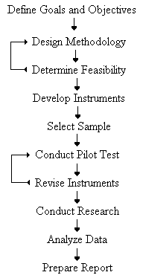

Advantages of Written Questionnaires

* **Questionnaires are very cost effective when compared to face-to-face interviews.** This is especially true for studies involving large sample sizes and large geographic areas. Written questionnaires become even more cost effective as the number of research questions increases.
* **Questionnaires are easy to analyze.** Data entry and tabulation for nearly all surveys can be easily done with many computer software packages.
* **Questionnaires are familiar to most people.** Nearly everyone has had some experience completing questionnaires and they generally do not make people apprehensive.
* **Questionnaires reduce bias.** There is uniform question presentation and no middle-man bias. The researcher's own opinions will not influence the respondent to answer questions in a certain manner. There are no verbal or visual clues to influence the respondent.
* **Questionnaires are less intrusive than telephone or face-to-face surveys.** When a respondent receives a questionnaire in the mail, he is free to complete the questionnaire on his own time-table. Unlike other research methods, the respondent is not interrupted by the research instrument.

## Disadvantages Of Written Questionnaires

One major disadvantage of written questionnaires is **the possibility of low response rates.** Low response is the curse of statistical analysis. It can dramatically lower our confidence in the results. Response rates vary widely from one questionnaire to another (10% - 90%), however, well-designed studies consistently produce high response rates.

Another disadvantage of questionnaires is **the inability to probe responses.** Questionnaires are structured instruments. They allow little flexibility to the respondent with respect to response format. In essence, they often lose the "flavor of the response" (i.e., respondents often want to qualify their answers). By allowing frequent space for comments, the researcher can partially overcome this disadvantage. Nearly ninety percent of all communication is visual. Gestures and other visual cues are not available with written questionnaires. The lack of personal contact will have different effects depending on the type of information being requested. A questionnaire requesting factual information will probably not be affected by the lack of personal contact. A questionnaire probing sensitive issues or attitudes may be severely affected.

When returned questionnaires arrive in the mail, it's natural to assume that the respondent is the same person you sent the questionnaire to. This may not actually be the case. Many times business questionnaires get handed to other employees for completion. Housewives sometimes respond for their husbands. Kids respond as a prank. For a variety of reasons, the respondent may not be who you think it is. It is a confounding error inherent in questionnaires.

Finally, **questionnaires are simply not suited for some people***.* For example, a written survey to a group of poorly educated people might not work because of reading skill problems.

## 

## Questionnaire Design - General Considerations

* Be sure to commit the study goals to writing.
* Formulate a plan for doing the statistical analysis during the design stage of the project.
* Make the envelope unique.
* Provide a well-written cover letter.
* Give your questionnaire a title that is short and meaningful to the respondent.
* Include clear and concise instructions on how to complete the questionnaire.
* Use simple and direct language.
* Leave adequate space for respondents to make comments.
* Place the most important items in the first half of the questionnaire.
* Hold the respondent's interest.
* Provide incentives as a motivation for a properly completed questionnaire.
* Use professional production methods for the questionnaire.

1. FACTOR ANALYSIS

Factor analysis is an interdependence technique in that an entire set of interdependent relationships is examined.

**Mathematically,** factor analysis is somewhat similar to multiple regression analysis, in that each variable is expressed as a linear combination of underlining factors. The amount variance a variable shares with all other variables included in the analysis is referred to as communality. The co variation among the variables is described in terms of small number of common factor plus a unique factor for each variable. If the variables are standardized, the factor model may be represented as:

**Xi = Ai1F1 + Ai2F2 + Ai3F3 + … + AimFm + ViUi**

Where

**Xi = ith standardized variable**

**Aij = standardized multiple regression coefficient of variable I on common factor j**

**F= common factor**

**Vi = standardized regression coefficient of variable I on unique factor I**

**Ui = the unique factor for variable i**

**m = number of common factors**

The unique factors are uncorrelated with each other and with the common factors.3 The common factors themselves can be expressed as linear combinations of the observed variables.

**Fi = Wi1x1 + Wi2X2 + Wi3X3 + … + WikXk**

**Where**

**Fi = estimate of i th factor**

**Wi = weight or factor score coefficient**

**k = number of variables**

***Key Concepts and Terms***

**Exploratory factor analysis (EFA**) seeks to uncover the underlying structure of a relatively large set of variables. The researcher's à priori assumption is that any indicator may be associated with any factor. This is the most common form of factor analysis. There is no prior theory and one uses factor loadings to intuit the factor structure of the data.

**Confirmatory factor analysis (CFA**) seeks to determine if the number of factors and the loadings of measured (indicator) variables on them conform to what is expected on the basis of pre-established theory. Indicator variables are selected on the basis of prior theory and factor analysis is used to see if they load as predicted on the expected number of factors. The researcher's à priori assumption is that each factor (the number and labels of which may be specified à priority) is associated with a specified subset of indicator variables. A minimum requirement of confirmatory factor analysis is that one hypothesize beforehand the number of factors in the model, but usually also expectations about which variables will load on which factors (Kim and Mueller, 1978b: 55).

**Factors and components**: Both are the dimensions (or latent variables) identified with clusters of variables, as computed using factor analysis. Technically speaking, factors (as from PFA -- principal factor analysis, a.k.a. principal axis factoring, a.k.a. common factor analysis) represent the common variance of variables, excluding unique variance, and is thus a correlation-focused approach seeking to reproduce the intercorrelation among the variables. By comparison, components (from PCA - principal components analysis) reflect both common and unique variance of the variables and may be seen as a variance-focused approach seeking to reproduce both the total variable variance with all components and to reproduce the correlations. PCA is far more common than PFA, however, and it is common to use "factors" interchangeably with "components."

* **Factor loadings:** The factor loadings, also called component loadings in PCA, are the correlation coefficients between the variables (rows) and factors (columns). Analogous to Pearson's r, the squared factor loading is the percent of variance in that variable explained by the factor. To get the percent of variance in all the variables accounted for by each factor, add the sum of the squared factor loadings for that factor (column) and divide by the number of variables. (Note the number of variables equals the sum of their variances as the variance of a standardized variable is 1.) This is the same as dividing the factor's eigenvalue by the number of variables.

In SPSS, the factor loadings are found in a matrix labeled Factor Matrix if PFA is requested, or in one labeled Component Matrix if PCA is requested, or one labeled Pattern Matrix if an oblique rotation is requested.

The sum of the squared factor loadings for all factors for a given variable (row) is the variance in that variable accounted for by all the factors, and this is called the communality. In a complete PCA, with no factors dropped, this will be 1.0, or 100% of the variance. The ratio of the squared factor loadings for a given variable (row in the factor matrix) shows the relative importance of the different factors in explaining the variance of the given variable. Factor loadings are the basis for imputing a label to the different factors.

**\* Communality, h2,** is the squared multiple correlation for the variable using the factors as predictors. The communality measures the percent of variance in a given variable explained by all the factors jointly and may be interpreted as the reliability of the indicator.

When an indicator variable has a low communality, the factor model is not working well for that indicator and possibly it should be removed from the model. However, communalities must be interpreted in relation to the interpretability of the factors. A communality of .75 seems high but is meaningless unless the factor on which the variable is loaded is interpretable, though it usually will be. A communality of .25 seems low but may be meaningful if the item is contributing to a well-defined factor. That is, what is critical is not the communality coefficient per se, but rather the extent to which the item plays a role in the interpretation of the factor, though often this role is greater when communality is high.

Communality for a variable is computed as the sum of squared factor loadings for that variable (row). Recall r-squared is the percent of variance explained, and since factors are uncorrelated, the squared loadings may be added to get the total percent explained, which is what communality is. For full orthogonal PCA, the communality will be 1.0 for all variables and all of the variance in the variables will be explained by all of the factors, which will be as many as there are variables. In the communalities chart, SPSS labels this column the "initial" communalities. The "extracted" communality is the percent of variance in a given variable explained by the factors which are extracted, which will usually be fewer than all the possible factors, resulting in coefficients less than 1.0. For PFA, however, the communalities for the various factors will be less than 1 even initially. Communality does not change when rotation is carried out, hence in SPSS there is only one communalities table.

* **Eigenvalues:** Also called characteristic roots. The eigenvalue for a given factor measures the variance in all the variables which is accounted for by that factor. The ratio of eigenvalues is the ratio of explanatory importance of the factors with respect to the variables. If a factor has a low eigenvalue**,** then it is contributing little to the explanation of variances in the variables and may be ignored as redundant with more important factors.

Thus, eigenvalues measure the amount of variation in thetotal sample accounted for by each factor. Note that the eigenvalue is not the percent of variance explained but rather a measure of "amount," used for comparison with other eigenvalues. A factor's eigenvalue may be computed as the sum of its squared factor loadings for all the variables. Note that the eigenvalues associated with the unrotated and rotated solution will differ, though their total will be the same.

* **Trace** is the sum of variances for all factors, which is equal to the number of variables since the variance of a standardized variable is 1.0. A factor's eigenvalue divided by the trace is the percent of variance it explains in all the variables, usually labeled percent of trace in computer output. Computer output usually lists the factors in descending order of eigenvalue, along with a cumulative percent of trace for as many factors as are extracted.

**\* Factor scores**: Also called component scores in PCA, factor scores are the scores of each case (row) on each factor (column). To compute the factor score for a given case for a given factor, one takes the case's standardized score on each variable, multiplies by the corresponding factor loading of the variable for the given factor, and sums these products. The SPSS FACTOR procedure saves standardized factor scores as variables in your working data file. By default it will name them FAC1_1,FAC2_1, FAC3_1, etc., for the corresponding factors (factor 1, 2 and 3) of analysis 1; and FAC1_2, FAC2_2, FAC3_2 for a second set of factor scores, if any, within the same procedure, and so on. Although SPSS adds these variables to the right of your working data set automatically, they will be lost when you close the dataset unless you re-save your data.

**\* Kaiser criterion**: A common rule of thumb for dropping the least important factors from the analysis. The Kaiser rule is to drop all components with eigenvalues under 1.0. Kaiser criterion is the default in most computer programs.

**\* Scree plot:** The Cattell scree test plots the components as the X axis and the corresponding eigenvalues as the Y axis. As one moves to the right, toward later components, the eigenvalues drop. When the drop ceases and the curve makes an elbow toward less steep decline, Cattell's scree test says to drop all further components after the one starting the elbow.

**\* Variance explained criteria**: Some researchers simply use the rule of keeping enough factors to account for 90% (sometimes 80%) of the variation.

**\* Rotation Methods**. Rotation serves to make the output more understandable and is usually necessary to facilitate the interpretation of factors. The sum of eigenvalues is not affected by rotation, but rotation will alter the eigenvalues of particular factors.

No rotation is the default in SPSS, but it is a good idea to select a rotation method, usually varimax. The original, unrotated principal components solution maximizes the sum of squared factor loadings, efficiently creating a set of factors which explain as much of the variance in the original variables as possible. The amount explained is reflected in the sum of the eigenvalues of all factors. However, unrotated solutions are hard to interpret because variables tend to load on multiple factors.

**\* Varimax rotation** is an orthogonal rotation of the factor axes to maximize the variance of the squared loadings of a factor (column) on all the variables (rows) in a factor matrix, which has the effect of differentiating the original variables by extracted factor. That is, it minimizes the number of variables which have high loadings on any one given factor. Each factor will tend to have either large or small loadings of particular variables on it. A varimax solution yields results which make it as easy as possible to identify each variable with a single factor. This is the most common rotation option.

**\* Quartimax rotation** is an orthogonal alternative which minimizes the number of factors needed to explain each variable.

**\* Equimax rotation** is a compromise between Varimax and Quartimax criteria.

**\* Direct oblimin rotation** is the standard method when one wishes a non-orthogonal solution -- that is, one in which the factors are allowed to be correlated. This will result in higher eigenvalues but diminished interpretability of the factors. See below.

**\* Promax rotation** is an alternative non-orthogonal rotation method which is computationally faster than the direct oblimin method and

therefore is sometimes used for very large datasets.

Steps in

Conducting Factor Analysis

Formulate the problem.

↓

Construct the correlation matrix.

↓

Determine the method of factor analysis.

↓

Determine the number of factors.

↓

Rotate the factors.

↓

## *Interpret the factors Variables*

↓

Calculate the Select the

Factor scores Surrogate

## 

.

↓

Determine the model fit

1. **RESEARCH OBJECTIVE & METHODLOGY**

* ***OBJECTIVE OF THE STUDY***

The main objective of this study are as follow:

***“To study the customer satisfaction towards bajaj motorcycles”.***

* ***METHODOLOGY***

The methodology adopted for collecting data and sample design is given below:

**A. COLLECTION OF DATA**

For collecting Primary Data from the users, a questionnaire was designed.

This questionnaire was administered to the consumers who use bajaj motorcycles services. Then a pilot survey was conducted to check the validity of the survey. Sample questionnaire is attached in annexure.

* 1. **SIMPLE RANDOM SAMPLING DESIGN**

SAMPLE SIZE : 253

SURVEY AREA : NARNAUL AND DELHI NCR(Hr.)

MODE OF SURVEY : ONLINE INTERVIEW

* 1. **STATISTICAL INTERPRETATION AND ANALYSIS**

The data obtained from primary survey was analyzed using tools like SPSS and Excel etc.

1. **DATA ANALYSIS**

**Demographic Information**

**Age Group**:-

|  |  |  |  |
| --- | --- | --- | --- |
| *Age(in Years)* | *Frequency* | *Percentage* | *Cumulative percentage* |
| 18-30 | *161* | *63.64%* | *63.64%* |
| 31-45 | *48* | *18.97%* | *82.61%* |
| 46-60 | *30* | *11.86%* | *94.47%* |
| above 60 | *14* | *5.53%* | *100.00%* |
| *total* | *253* | *100.00%* |  |

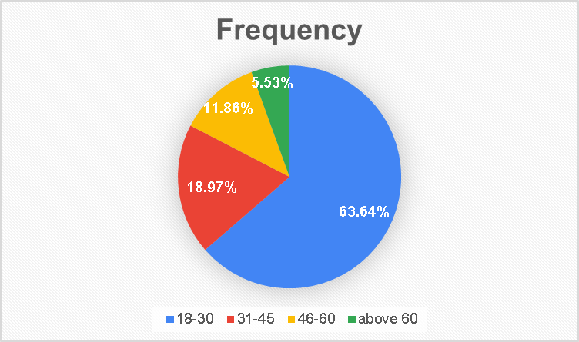

**Interpretation**

We can observe from the frequency distribution and the pie chart that the respondents of the survey are in majority with 161 , from the age group 18-30.we have 48 respondents in age group 31-45,30 in age group 46-60 and 14 are above 60 years of age. This frequency is a result of random sampling as no particular age group has been targeted.

**Occupation:**

|  |  |  |  |
| --- | --- | --- | --- |
| *Occupation* | *Frequency* | *Percentage* | *Cumulative percentage* |
| Student | *116* | *45.85%* | *45.85%* |
| Private employee | *61* | *24.11%* | *69.96%* |
| Government employee | *40* | *15.81%* | *85.77%* |
| Self employee | *34* | *13.44%* | *99.21%* |
| Retired | *1* | *0.40%* | *99.60%* |
| Retirement | *1* | *0.40%* | *100.00%* |
| Total | 253 | 100.00% |  |

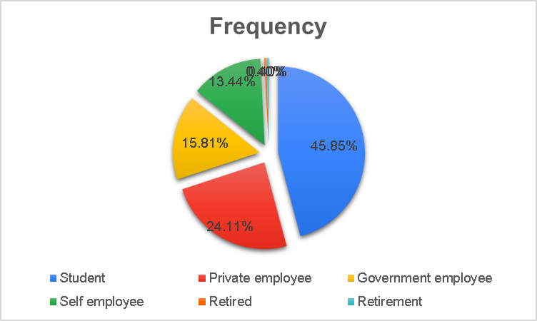

**Interpretation**

We can observe from the frequency distribution and the graph above that out of a total of 253 respondents,116 are students ,61 are serving in private jobs,40 are serving in govt jobs and 34 have their own business and rest are retired.

**Average annual income ( in rupees ):**

|  |  |  |  |
| --- | --- | --- | --- |
| *Annual income (in rupees )* | *Frequency* | *Percentage* | *Cumulative percentage* |
| 3 lac | *47* | *18.58%* | *18.58%* |
| 3 lac -6 lac | *99* | *39.13%* | *57.71%* |
| 6 lac - 9 lac | *72* | *28.46%* | *86.17%* |
| above 9 lac | *35* | *13.83%* | *100.00%* |
| *total* | *253* | *100.00%* |  |

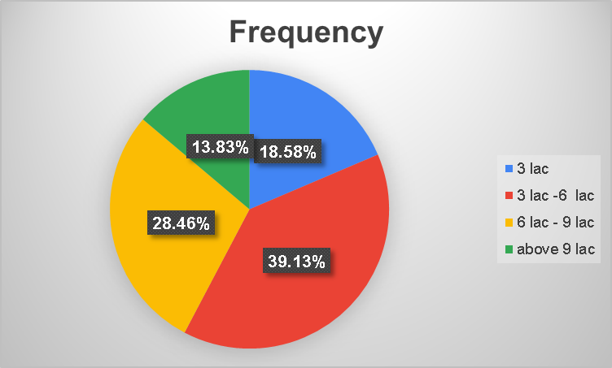

**Interpretation**

From the above pie chart it is clearly observed that the majority of respondents belongs families whose average annual income is 3Lac-6Lac(99) followed by the families whose annual income is 6Lac-9Lac(72). 47 respondents belong to the families with avg. annual income is 3Lac and 35 respondents belong to above 9Lac annual income group.

**Different Bajaj Motordcycles Models prefered by the respondents:-**

|  |  |  |  |
| --- | --- | --- | --- |
| *Models* | *Frequency* | *Percentage* | *Cumulative percentage* |
| CT100 | *24* | *9.49%* | *9.49%* |
| Discover | *28* | *11.07%* | *20.55%* |
| Platina | *38* | *15.02%* | *35.57%* |
| Pulsar | *70* | *27.67%* | *63.24%* |
| Avenger | *45* | *17.79%* | *81.03%* |
| Dominar | *35* | *13.83%* | *94.86%* |
| V | *13* | *5.14%* | *100.00%* |
| *Total* | *253* | *100.00%* |  |

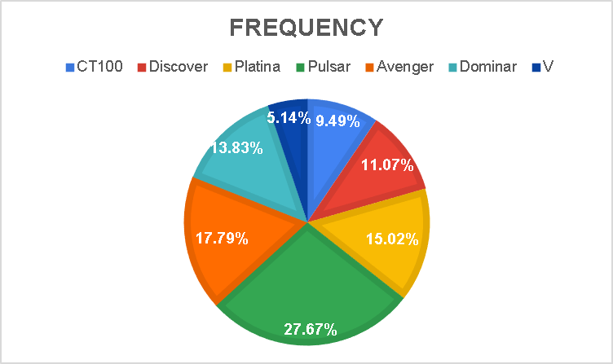

**Interpretation**

Highest no. of respondents(70) own pulsar followed by 45 who own Avenger. 38 respondents own platina, 35 own Dominar, 28 own Discover, 24 own CT100 and only 13 respondents own V model of Bajaj motorcycles.

**How did you come to know about Bajaj Motorcycle?**

|  |  |
| --- | --- |
| *Options* | *Frequency* |
| Newspaper | *99* |
| Friends | *155* |
| Television | *155* |
| Saw Bajaj bike on road | *17* |
| Advertisements | *87* |
| Other | *2* |

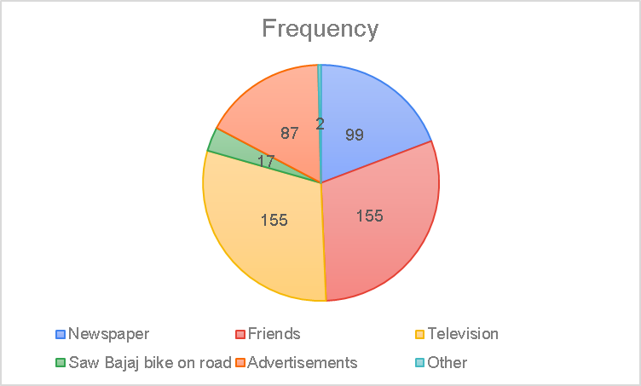

**Interpretation**

Highest no. of respondents i.e 155 came to know about bajaj through friends and television, 99 through newspaper , 87 through other advertisments ,17 through saw bajaj bike on road and rest through others.

|  |  |
| --- | --- |
|  |  |

**How long have you been a bajaj motorcycle customer?**

|  |  |  |  |
| --- | --- | --- | --- |
| *Time period* | *Frequency* | *Percentage* | *Cumulative percentage* |
| less than 1 year | *45* | *17.79%* | *17.79%* |
| 1-3 year | *105* | *41.50%* | *59.29%* |
| 3-6 year | *74* | *29.25%* | *88.54%* |
| more than 6 year | *29* | *11.46%* | *100.00%* |
| *Total* | *253* | *100.00%* |  |

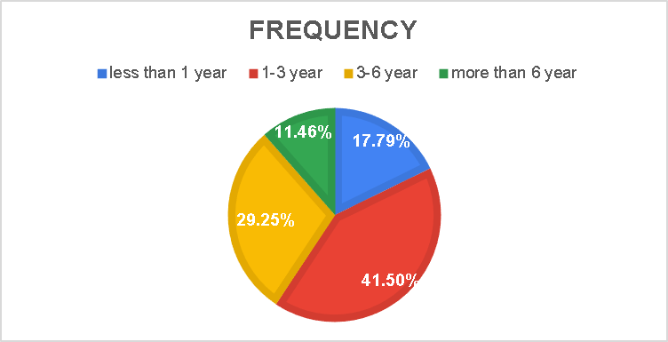

**INTERPRETATION**

Out of the 253 respondents surveyed, mostly i.e. 41.5% of the people belong to the category who have been customers of bajaj from the past 1-3 years.29.2% belong to 3-6 years, 17.8% belong to less than 1 year, and 11.5% belong to more than 6 year.

From the above chart it can be inferred that most of the people prefer bajaj over other brands because of its brand image. Attributes such as value for money, mileage and design also are major attributes attracting people towards bajaj motorcycles.

**Q.** **How likely are you to recommend Bajaj bike to others ?**

|  |  |
| --- | --- |
| **Rating Scale** | **Frequency** |
| **1** | **1** |
| **2** | **0** |
| **3** | **1** |
| **4** | **0** |
| **5** | **2** |
| **6** | **6** |
| **7** | **28** |
| **8** | **46** |
| **9** | **56** |
| **10** | **45** |

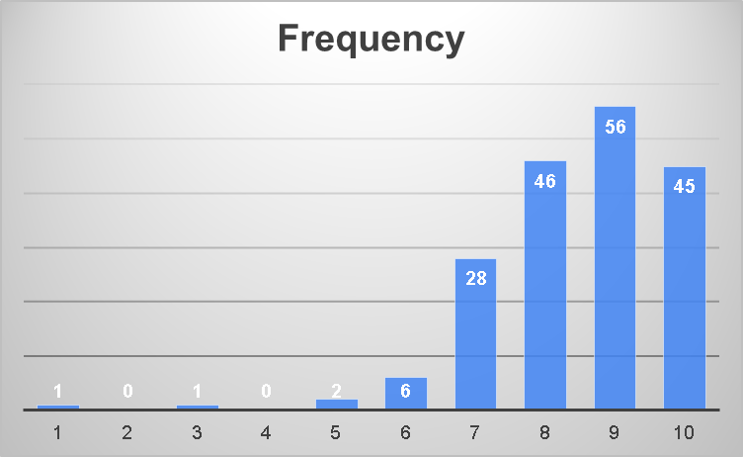

**Interpretation**

From the above graph we can infer that most of the people are very satisfied and have given a rating of 9 followed by even higher rating of 8.

**Q. What are the areas where you would like the company to improve?**

|  |  |
| --- | --- |
| *Improvement needed in* | *Frequency* |
| Design | *21* |
| Brake | *12* |
| Pickup | *7* |
| Mileage | *14* |
| Durability | *1* |
| Engine | *13* |
| *Total* | *68* |

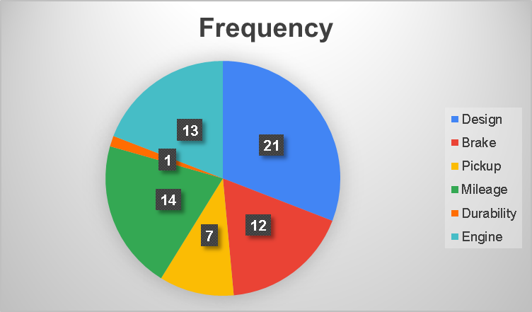

**Interpretation**

From the above graph we can see that the most respondents would like the company to imrove is that of Design followed by engine and Mileage problem. Brake and pickup problem falls on 4th place, closely followed by durability problems.

**Q.Would you recommend bajaj Motorcycles to others?**

|  |  |
| --- | --- |
| Response | Frequency |
| Yes | 185 |
| No | 20 |
| Maybe | 48 |
| Total | 253 |

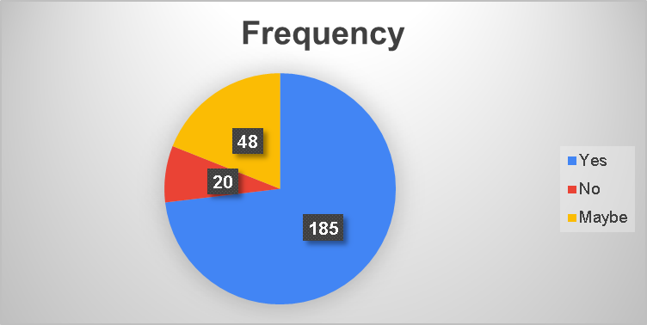

**Interpretation**

From the above data we can observe large no. of bajaj customers(185) are more likely to recommend bajaj motorcycles to others

**Conclusion based on Demographic Data:-**

* Most of the Bajaj customers are generally young and lie in the age bracket of 18-30.
* The most appealing and used model of bajaj motorcycle is the *pulsar*.
* Most of the people got to know about bajaj through friends and television.
* Most of the customers prefer bajaj because of its brand image.
* Most of the customers are highly satisfied with riding experience of bajaj motorcycles.
* Most respondents would like the company to improve was found with the design and mileage.
* Most of the customers were willing to suggest others to buy a bajaj motorcycle.
* A major concern received through feedback was of gearbox and rusting problem in motorcycles.
* The report shows that the customers are highly satisfied by overall performance of bajaj motorcycle which is a good sign but still some improvements have to be made on the technical front.

**Factor Analysis**

|  |  |  |  |
| --- | --- | --- | --- |
| **Descriptive Statistics** | | | |
|  | Mean | Std. Deviation | Analysis N |
| Better Mileage | 3.41 | 1.071 | 253 |
| Engine capacity | 3.41 | 1.590 | 253 |
| Customer Service | 3.15 | 1.098 | 253 |
| Better Design | 3.58 | 1.290 | 253 |
| Brand image | 3.70 | 1.219 | 253 |
| Better price | 3.70 | 1.203 | 253 |
| Technology | 3.43 | 1.137 | 253 |
| Durability | 3.08 | 1.397 | 253 |
| More comfort | 2.80 | 1.478 | 253 |
| Better colour option | 3.50 | 1.373 | 253 |
| Free accessories | 3.01 | 1.065 | 253 |
| Spare part supply | 3.85 | .993 | 253 |

|  |  |  |
| --- | --- | --- |
| **Communalities** | | |
|  | Initial | Extraction |
| Better Mileage | 1.000 | .494 |
| Engine capacity | 1.000 | .684 |
| Customer Service | 1.000 | .567 |
| Better Design | 1.000 | .704 |
| Brand image | 1.000 | .483 |
| Better price | 1.000 | .691 |
| Technology | 1.000 | .414 |
| Durability | 1.000 | .633 |
| More comfort | 1.000 | .487 |
| Better colour option | 1.000 | .619 |
| Free accessories | 1.000 | .531 |
| Spare part supply | 1.000 | .625 |

|  |
| --- |
| Extraction Method: Principal Component Analysis. |

The proportion of variance in any one of the original variables which is captured by extracted factor is known as communality.

|  |  |  |
| --- | --- | --- |
| **KMO and Bartlett's Test** | | |
| Kaiser-Meyer-Olkin Measure of Sampling Adequacy. | | .784 |
| Bartlett's Test of Sphericity | Approx. Chi-Square | 899.431 |
| Df | 66 |
| Sig. | .000 |

From the data we have got the KMO value as 0.784 >0.5. thus factor analysis is appropriate to use in this case thus we can further proceed with the analysis.

|  |  |  |  |  |  |  |
| --- | --- | --- | --- | --- | --- | --- |
| **Total Variance Explained** | | | | | | |
| Component | Initial Eigenvalues | | | Extraction Sums of Squared Loadings | | |
| Total | % of Variance | Cumulative % | Total | % of Variance | Cumulative % |
| 1 | 3.819 | 31.826 | 31.826 | 3.819 | 31.826 | 31.826 |
| 2 | 1.901 | 15.839 | 47.665 | 1.901 | 15.839 | 47.665 |
| 3 | 1.212 | 10.102 | 57.767 | 1.212 | 10.102 | 57.767 |
| 4 | .977 | 8.138 | 65.905 |  |  |  |
| **5** | **.**740 | 6.165 | 72.070 |  |  |  |
| 6 | .717 | 5.979 | 78.049 |  |  |  |
| 7 | .625 | 5.204 | 83.254 |  |  |  |
| 8 | .568 | 4.731 | 87.984 |  |  |  |
| 9 | .422 | 3.517 | 91.502 |  |  |  |
| 10 | .382 | 3.186 | 94.688 |  |  |  |
| 11 | .348 | 2.904 | 97.592 |  |  |  |
| 12 | .289 | 2.408 | 100.000 |  |  |  |

|  |  |  |  |
| --- | --- | --- | --- |
| **Total Variance Explained** | | | |
| Component | Rotation Sums of Squared Loadings | | |
| Total | % of Variance | Cumulative % |
| 1 | 3.461 | 28.842 | 28.842 |
| 2 | 1.786 | 14.880 | 43.722 |
| 3 | 1.685 | 14.045 | 57.767 |

|  |
| --- |
| Extraction Method: Principal Component Analysis. |

From the 12 attributes, 3 factors have been extracted, factors with Eigen values more than one are assumed to be extracted.

The above table tells that after 3 factors exrtracted and retained, the communality is 0.494 for variable 1, 0.684 for variable 2 and so on, (all values are labeled communality in the above table). This means that 49.4% of the variance information content of variable 1 is captured by 3 factors extracted together and so on.

The first step in interpreting the output is to look for the factors extracted, their Eigen values and cumulative percentage of variance. We consider 3 factors because the Eigen values for these is greater than 1. We see the cumulative percent column that the three factors extracted account for 57.767% that is approximately 58 of total variance.

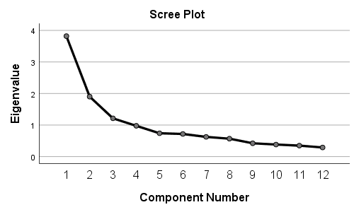

After observing the scree plot we can conclude that there are 3 factors that have to be extracted from the original 12 variable.

|  |  |  |  |
| --- | --- | --- | --- |
| **Rotated Component Matrixa** | | | |
|  | Component | | |
| 1 | 2 | 3 |
| Better Mileage | .090 | .487 | .499 |
| Engine capacity | .783 | .149 | -.220 |
| Customer Service | .190 | .723 | .090 |
| Better Design | .834 | .056 | .073 |
| Brand image | .524 | .423 | .172 |
| Better price | -.037 | -.050 | .829 |
| Technology | .638 | .018 | -.078 |
| Durability | .593 | .491 | -.200 |
| More comfort | -.686 | .120 | -.040 |
| Better colour option | .766 | .180 | .020 |
| Free accessories | -.095 | .723 | -.011 |
| Spare part supply | -.081 | .091 | .781 |

|  |
| --- |
| Extraction Method: Principal Component Analysis.  Rotation Method: Varimax with Kaiser Normalization. |
| a. Rotation converged in 5 iterations. |
|  |

.

**Factor analysis Interpretation**

Respondents were asked to rate the various attributes of their level of satisfaction with their bajaj motorcycle on the scale of (1-5).

This scale was –

* 1. Highly dissatisfied.
  2. Somewhat dissatisfied
  3. Neutral
  4. Somewhat satisfied
  5. Highly satisfied

Out of 12 variables we are able to reduce them to 3 factors which are free from redundancy. After the stastical computations factoring have been completed. The next step is of interpreting these factors.

this is achieved by inspecting the pattern of high and low loading of each of the factors on the variables.

**Factor 1:- Determinant Attributes**

|  |  |
| --- | --- |
| **Attribute** | **Factor Loading** |
| Engine capacity | 0.783 |
| Better Design | 0.834 |
| Brand image | 0.524 |
| Technology | 0.638 |
| Durability | 0.593 |
| Better colour option | 0.634 |

**Interpretation:**

Factor 1 comprises of six attributes that take into account the features relating to life cycle of the motorcycle. These factors influence the consumers to buy a certain motorcycle. Out of the six variables, the second variable Better design influences the most within the factor. This attribute has the highest factor loading of 0.834 followed by Engine capacity.

Better colour option and Technology follow the previously mentioned attributes that influence the customer satisfaction.

Thus as a whole this factor has significant importance for a customer’s satisfaction.

**Factor 2 : Brand and Service**

|  |  |
| --- | --- |
| Attribute | Factor Loading |
| Customer service | 0.723 |
| Free accessories | 0.723 |
| More comfort | 0.120 |

**Interpretation:**

The second factor comprises of attributes that are related to customer service and free accessories of the motorcycle. Again all the factors have high factor loading. The most important attributes are the customer service and free accessories of Motorcycle followed by More comfort of the motorcycle which is also important.

It is clear that the customer are satisfied by first two attributes and gives lot of importance to these two attributes.

**Factor 3 : Brand and Price**

|  |  |
| --- | --- |
| Attribute | Factor Loading |
| Better mileage | 0.499 |
| Better price | 0.829 |
| Spare part supply | 0.781 |

**Interpretation:**

This factor consists of attributes that are related to the price of motorcycles. It is clear from the above table that all the factors have reasonably high factor loading means that this factor is also important. This factor tells about customer satisfaction for the Better price, better mileage and spare part supply of bajaj motorcycles. Better price has the highest factor loading i.e. 0.829 in the above factor followed by spare part supply i.e. spare part supply attribute affect purchase of the motorcycle.

1. **SWOT ANALYSIS**

SWOT analysis is a strategic planning tool used to evaluate the **Strengths, Weaknesses, Opportunities, and Threats** involved in a project or in a business venture or in any other situation of an organization or an individual requiring a decision in pursuit of an objective. It involves monitoring the marketing environment, internal or external to the organization or individual. The technique is credited to Albert Humphrey, who led a research project at Stanford University in the 1960s and 1970s using data from Fortune 500 companies.

SWOT can be used as a basis for the analysis of business and environment factors. It is a technique widely used by a group, department, unit, organization, or even an individual. SWOT analysis can be contained within and fed into an individual’s continued professional development.

**The strategic and creative use of SWOT analysis**

Strategic use: Orienting SWOTs to an objective- If SWOT analysis does not start with defining a desired end state or objective, it runs the risk of being useless. A SWOT analysis may be incorporated into the strategic planning model.

If a clear objective has been identified, SWOT analysis can be used to help in the pursuit of that objective. In this case, SWOTs are:

**Strengths:** Attributes of the organization those are helpful to achieve the objective

**Weaknesses:** Attributes of the organization those are harmful in achieving the objective

**Opportunities:** External conditions those are helpful in achieving the objective

**Threats:** External conditions those are harmful in achieving the objective

Correct identification of SWOTs is essential because subsequent steps in the process of planning for achievement of the selected objective are to be derived from the SWOTs.

First, the decision makers have to determine whether the objective is attainable, given the SWOTs. If the objective is not attainable a different objective must be selected and the process repeated.

Creative use of SWOTs- If the objective seems attainable. The SWOTs are used as inputs to the creative generation of possible strategies, by asking and answering each of the following questions, many times

* + - * 1. How can we use each strength?
        2. How can we stop each weakness?
        3. How can we exploit each opportunity?
        4. How can we defend against each threat?

**Internal and External Factors**

The aim of any SWOT analysis is to identify the key external and internal factors that are important in achieving the objective. SWOT analysis groups key pieces of information into two main categories:

* External factors: Opportunities and threats presented by the external environment.
* Internal factors: The strengths and weaknesses internal to the organization.

The internal factors may be viewed as strengths or weaknesses depending upon their impact on the organization’s objectives. What may represent strength with respect to one objective may be weaknesses for another objective. The factors may include all of the 4Ps as well as personnel, finance, manufacturing capabilities and so on. The external factors may include macroeconomic matters, technological change, legislation, and socio-cultural changes, as well as changes in the market place or competitive position. The results are often presented in the form of a matrix.

SWOT analysis is just one method of categorization and has its own weakness. For example, it may tend to persuade companies to compile lists rather than think about what is really important in achieving objectives. It also presents the resulting lists uncritically and without clear prioritization so that, for example, weak opportunities may appear to balance strong threats.

It is prudent not to eliminate too quickly any candidate SWOT entry. The importance of individual SWOTs will be revealed by the value of the strategies it generates. A SWOT item that produces valuable strategies is important. A SWOT item that generates no strategies is not important.

**BAJAJ**

|  |  |
| --- | --- |
| **Bajaj Auto SWOT Analysis** | |
| Strengths | 1. Excellent brand presence and marketing in India make Bajaj Auto a popular company 2. Extensive research and development focus and highly experienced player in the motorcycle segment 3. Widespread distribution network of Bajaj Auto across India 4. Bajaj Auto has a wide product range in terms of price, quality and categories 5. Featured in the Forbes Global brands list  6. It has more than 9000 people employed in the organization |
| Weaknesses | Here are the weaknesses of Bajaj Auto Limited :  1.Bajaj Auto is still not a global brand despite high volume production 2.Lack of performance bikes like major international brands and sports bikes & cruisers |
| Opportunities | Following are the Opportunities of Bajaj Auto Limited :  1. Cheaper variants for tapping more in the rural segment 2. Premium sports bikes for urban areas 3. Constant growth in the two-wheeler segment |
| Threats | The threats of Bajaj Auto Limited are as mentioned :  1. Cheaper imports from countries like China can affect business for Bajaj 2. Entry of international brands 3.Other motorcycle players have a strong brand presence |

10. Questionnaire through which this survey has been done

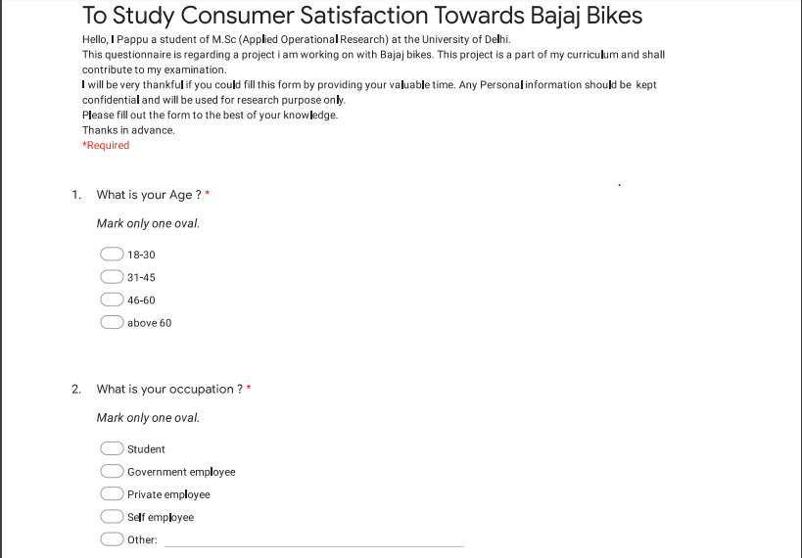



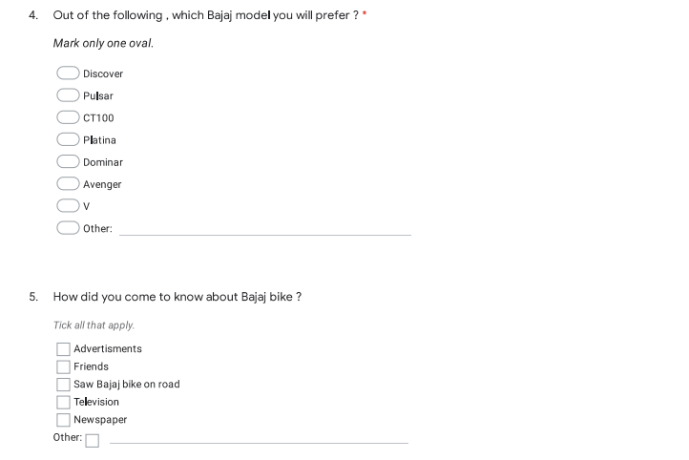

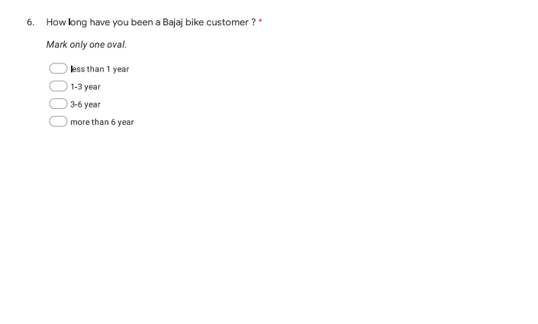

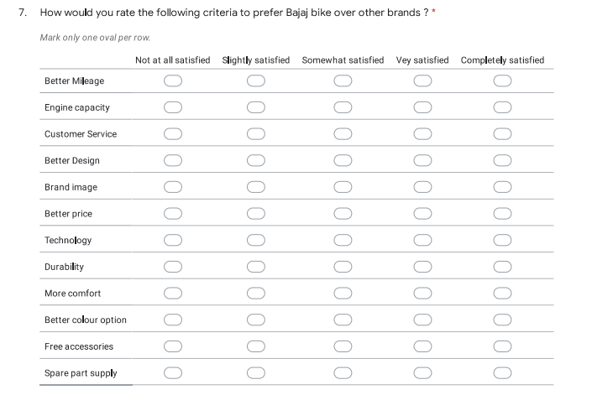

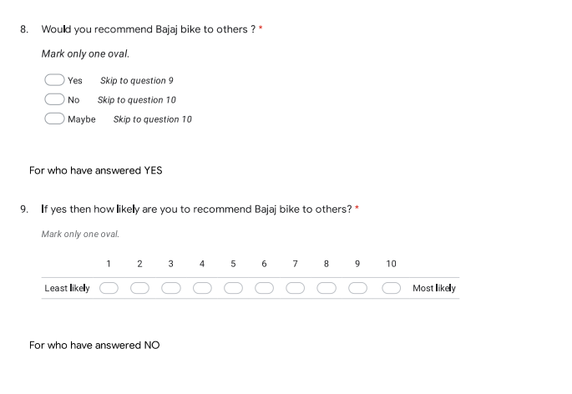

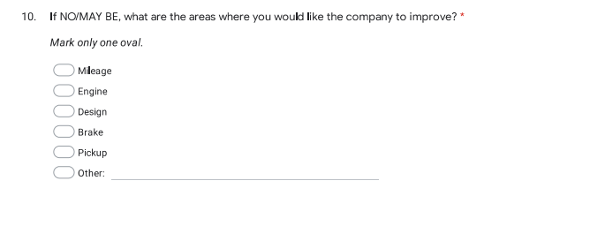

##### BIBLIOGRAPHY

The following books and websites were referred to in the execution of this project

1. **FUNDAMENTALS OF APPLIED STATISTICS**

*S.C.GUPTA & V.K.KAPOOR*

*Sultan Chand & Sons*

1. **MARKETING RESEARCH** sss

N.K.MALHOTRA

Pearson Education,Inc.

3. **STATISTICAL METHODS**

*S.P.GUPTA*

*Sultan Chand & Sons*

4**. INTRODUCTION TO OPERATIONAL RESEARCH**

*HILLER &LIEBERMAN*

*Tata McGraw-Hill Edition*

5. **MARKETING RESEARCH**

*David A. Aaker, V.kumar, George.S.Day*

*John Wiley & Sons,Inc*

**SITES :**

[www.google.com](http://www.google.com/)

[www.bajajauto.](http://www.bajajauto.)com

[www.wikipedia.org](http://www.wikipedia.org)